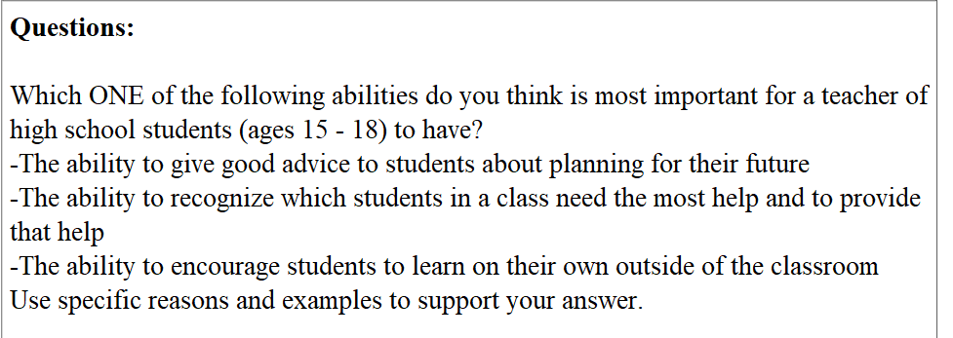

Since the dawn of human civilization, teachers have always been the most respectful job in every civilization, especially for those high school teachers in recent years. To be a successful high school teacher, some would claim that they need the ability to detect students that are in need and thus helping them, while others opposes by pointing out that high school teachers need to have the ability to give suggestions and help planning students’ futures or to help students learn outside of the classroon on their own. As far as I am concerned, the most important ability for a high school teacher should be recognizing and helping stduents that are in trouble. Here follow my reasons.

First and formost, high school students nowadays face a lot of pressure, as they have to deal with various tasks such as group work, preparing for their presentations, writing essays, and meeting various deadlines. Hardly can not a junior high school student feel any depression in their daily lives, let alone high schoolers that are facing massive workloads. Thus the ability to recognize students that need most help and also helping them to express or relieve their pressure will be the most important for those teachers. If students are not able to express or relieve their depression, these emotions will lead to serious mental problems, such as suicide. Take my friend John as an exmaple, when he was in his highschool, he got a lot of depression from his strict parents. Everyday he seems to be depressed. My teacher, however, found out his problem and helped him to negotiate with his perents. At last, John relieved all his depression and his grade soon got back to normal.

Secondly, students may also need help in their studying, which is the most important task for a student. Finding out who have problems with studying and helping them is also an important requirement for a teacher. Take myself as an exmaple, when I was in the first year of high school, I got a really bad grade. However, my teacher found my problem and helped with my mathmatics in the weekend. When it comes to an end of the first year, my Mathmatics got a full mark in the test, and now I am able to help others with their mathmatics.

Last but not least, high school students do not need to plan thir future career st their age, since most of them are going to the university, where they get plenty time considering about their future career. If they use their precious time in high school to consider their future, they may be left behind by others and thus even loosing the ability to attend a college, let alone their future. What is more, students come to high school to study but not learn outside the classroom. Encouraging them to learn outside the classroom will not benefit them at all.

From all of above, it is safe to draw the conslusion that the most important ability for a high school teacher is to find out students in need and solve their problams.